Uploading Your Own Image to Balsamiq  
By Rebecca Russell

In order to add your own image to Balsamiq.com. You first must have a mockup open. I will use a blank mockup for this tutorial.

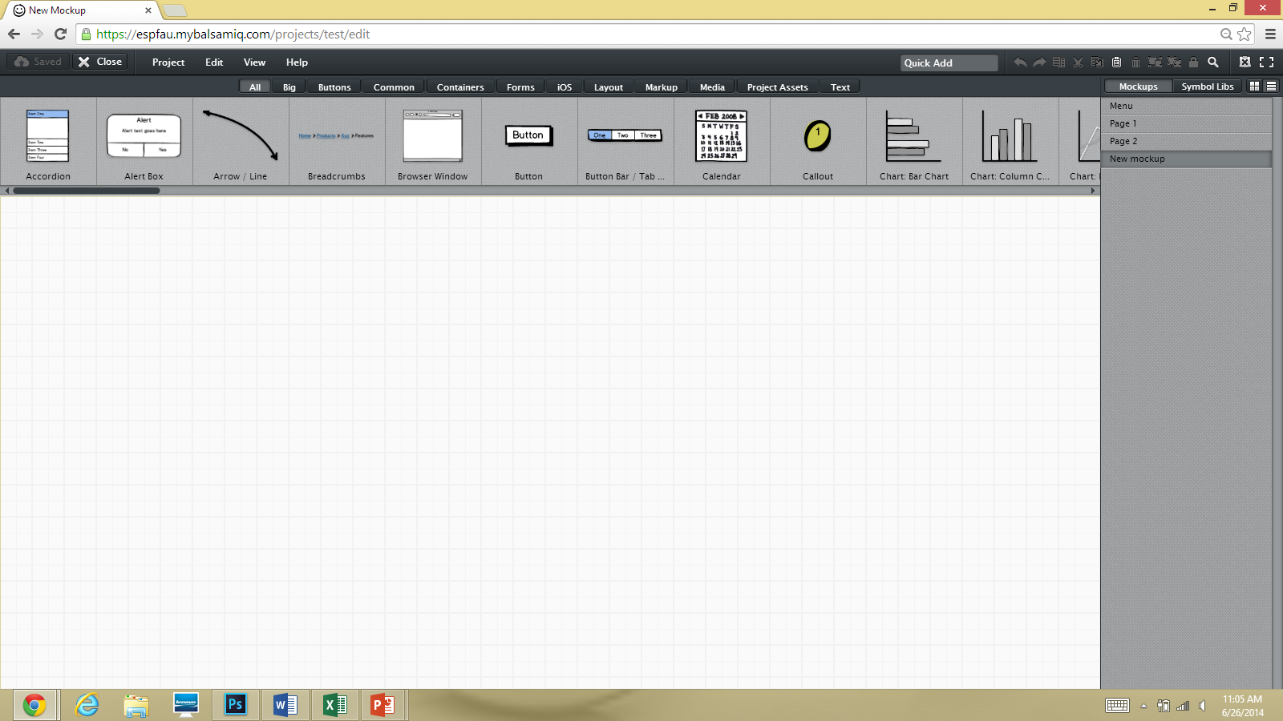

There are two ways to find the “Image” icon. You can click on the tabs and scroll through the icons in the red box until you find it. Or, you can click on the “Quick Add” text box to search for the icon you wish to apply to your mockup. I will use the Quick Add feature to find the image icon.

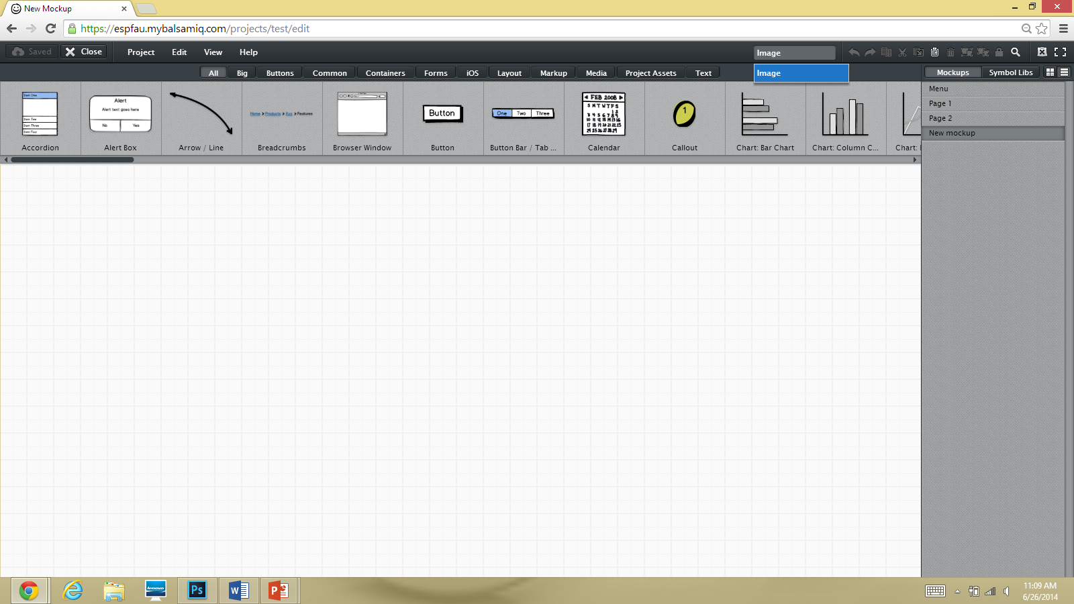

Drop Down Menu

Quick Add

So, I entered the word “Image” into the “Quick Add” text box. You can enter the first few letters and select the desired icon from the drop down menu that appears. Next, I will click on the word “Image” from the drop down menu.

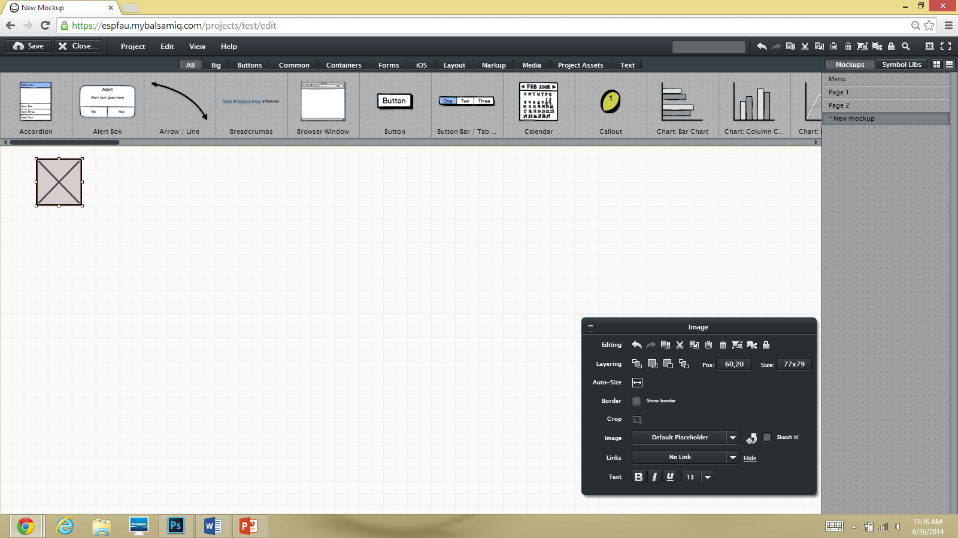

Now our Image icon is visible and a properties box for the Image icon has appeared. The image icon can remain in the way it is now if you just wish to show that an image will be there. However, we wish to insert an image of our own into the mockup. I zoomed in to the Image properties box for more clear instructions.

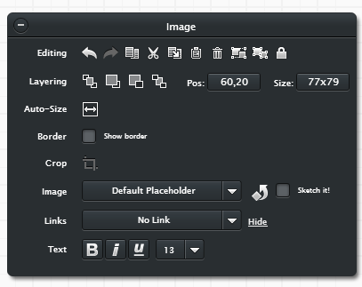

The properties box enables you to change many aspects of the image such as size, position, and text. For our purposes we will focus on the Image feature. Click on the drop down box next to the word “Image.” A pop up box will appear prompting you to select an image to insert.

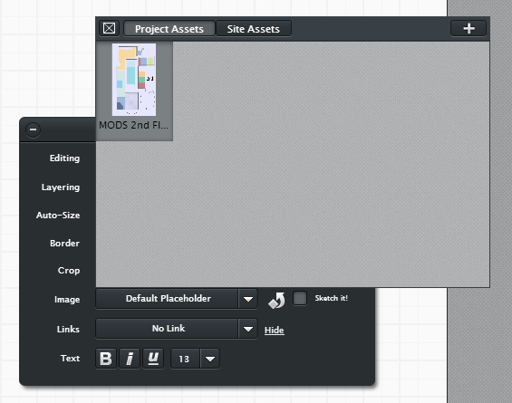

I already have inserted an image into this project folder so it is appearing. To insert a new image click on the plus sign (+) in the top right hand corner of the box.

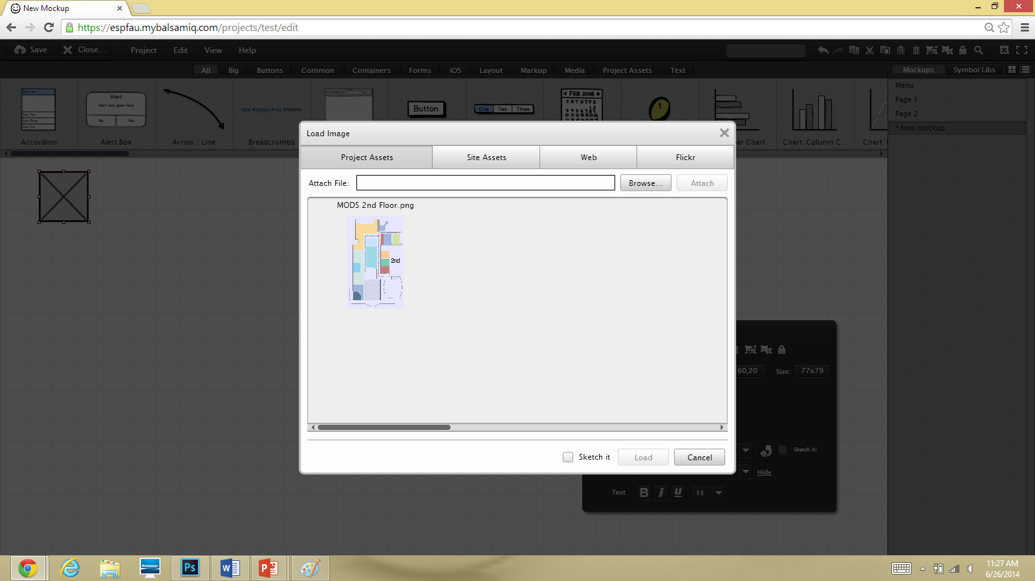  
This screen should now appear. Click Browse to locate the file to insert into the image icon.

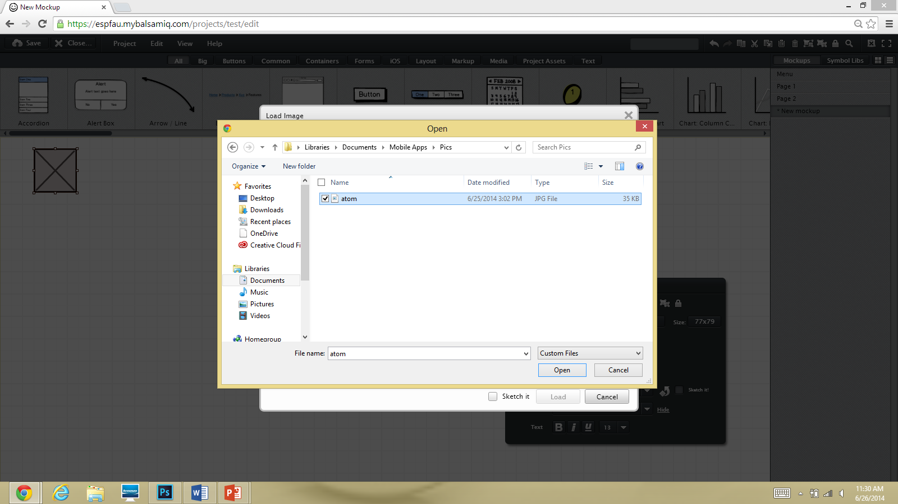

Find the location of the picture and click the picture and click open.

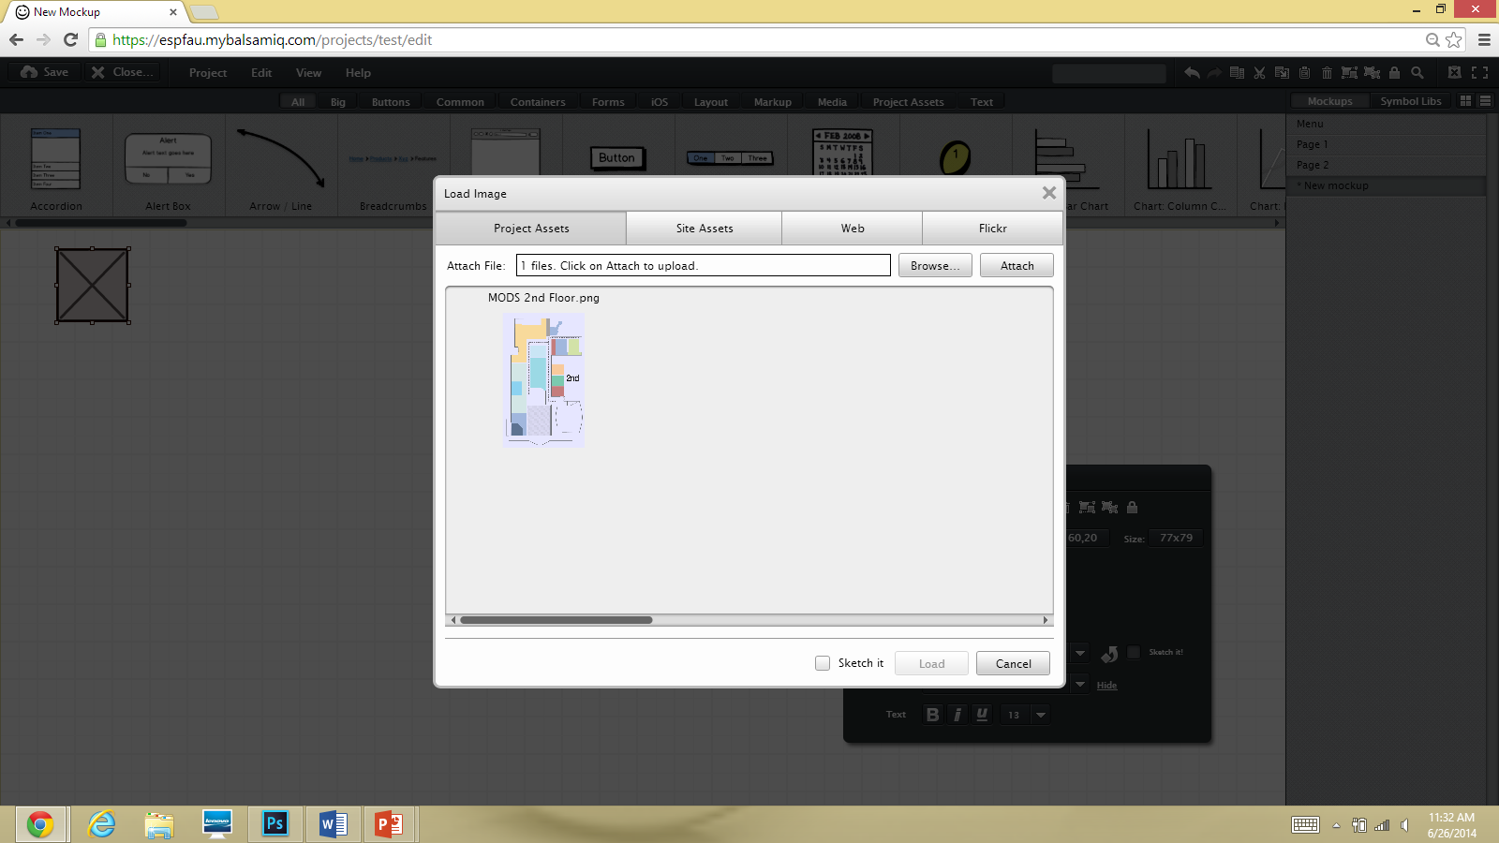

The file is now ready to attach. Click the “Attach” button to upload your image into Balsamiq.

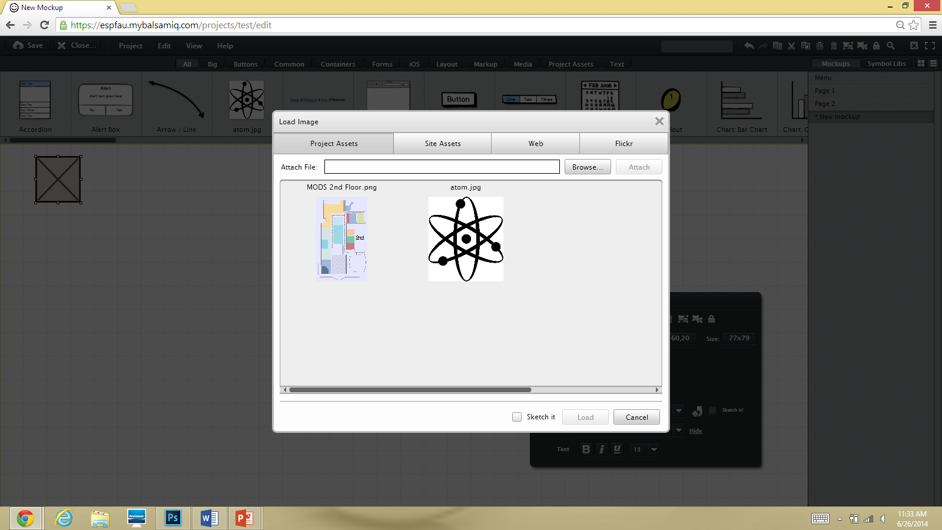

Now, my image “atom.jpg” is loaded to balsamiq. The last step is to click on the image you wish to insert (in my case, the picture of the atom) and click “Load.”

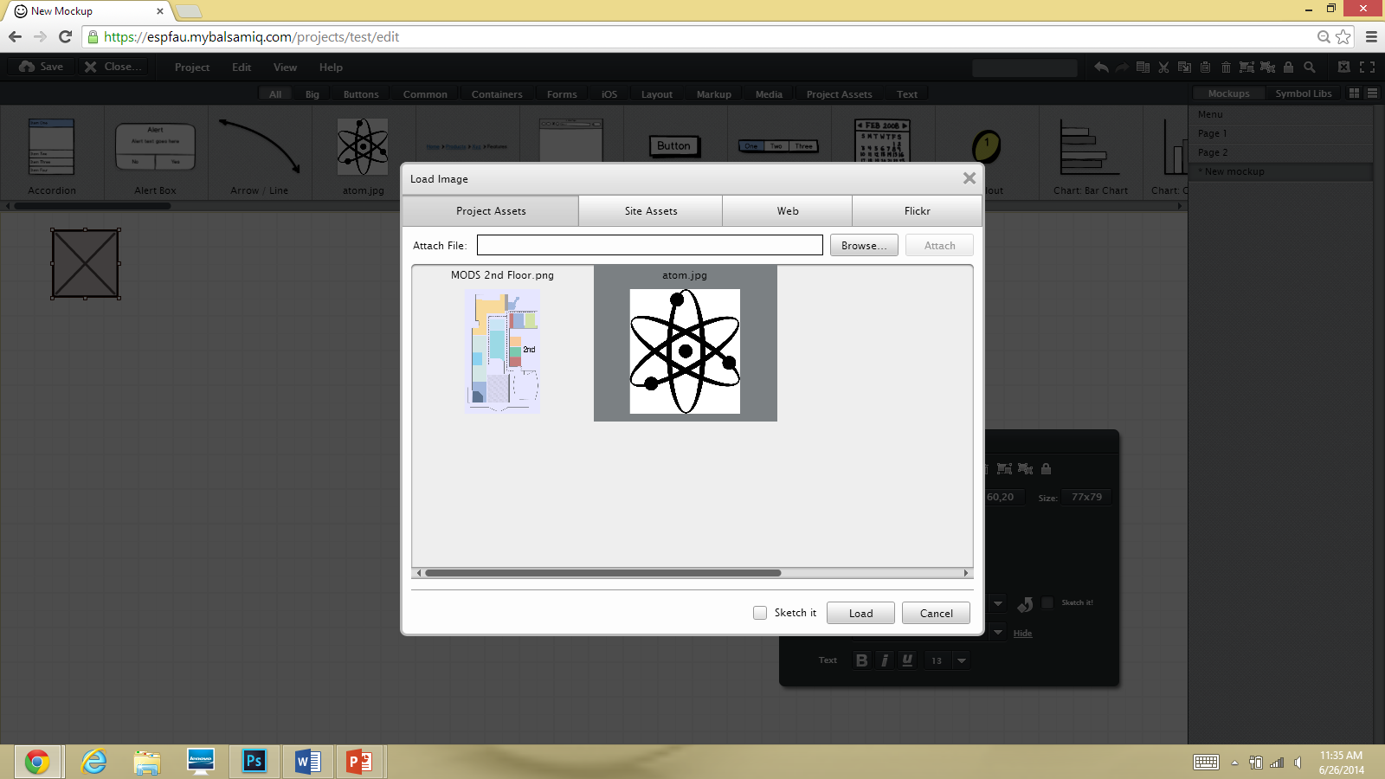

Now, my image is uploaded into the current mockup.

